ESPFC Project Newsletter
Issue 3, 2014

Interview with Vugar Gulmammadov, Chairman of Chamber of Accounts
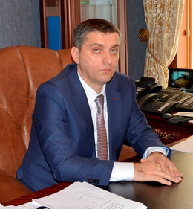

As you have known, a group of public unions have been working to conduct researches and prepare proposals in the framework of the European Commission funded "Enhancing Effectiveness of Public Finance Control Project." What do you think of the cooperation between the Chamber of Accounts and these organizations? How can it be organized?

In general, it is inevitable to ensure a number of factors and preconditions in order to obtain more effective results in the context of progressive public management.

One of these terms relates to attaching special importance to the participation of citizens and civil society organizations in different aspects of public and social life, such as decision-making on national level, organizing public oversight on government agencies and increasing public accountability.

Establishing relations with the Supreme Audit Institutions is of great importance to raise public awareness of the external control on public finances, given particularly the impact that citizens, civil society organizations and public unions have upon ensuring the effective control through public debate.
Contents:

• Interview with Vugar Gulmammadov, Chairman of Chamber of Accounts (page 1);

• Next project workshop organized in Shaki (page 3);

• Conference organized on the topic of external audit of public finance (page 3);

• Radio discussions held on public finance management and control (page 4);

In terms of ensuring efficient implementation of audit recommendations and building the confidence of citizens in the SAI, broad discussions with civil society institutions have positive impact on enhancing the value and benefit of external control over public finance.

We hope that mutual cooperation will positively contribute to “Enhancing Effectiveness of External Control Project,” carried out by a group of public unions with support of the European Commission.

The Chamber of Accounts has a short history of establishment and development, to what extent are international cooperation as well as study and application of international experience embedded in its activity? Please impart what impacts it has on the audit mission of the Chamber.

Since its inception, the Chamber of Accounts have signed cooperation agreements with the International Organization of Supreme Audit Institutions (INTOSAI) and its regional Working Groups, the European Organization of Supreme Audit Institutions (EUROSAI), the Asian Organization of Supreme Audit Institutions (ASOSAI), member states of the Economic Cooperation Organization Supreme Audit Institutions (ECOSAI), the Council of Heads of Supreme Financial Audit Institutions of the Commonwealth of Independent States as well as supreme audit institutions of several foreign countries with development history and advanced experience.

Developing and strengthening of bilateral and multilateral relations with these organizations as well as authorities of foreign countries, which undertake audit functions, plays an important role in improving the activity of the Chamber.

In order to ensure the implementation of the Public Sector Accountability Component, which aims at building the capacity of Chamber of Accounts, of the World Bank administered Corporate and Public Sector Accountability Project (CAPSAP), in the frame of the Agreement on Technical Assistance signed between the Government of the Swiss Confederation and the Government of the Republic of Azerbaijan, works are currently in progress for improving legislative acts regulating activities of the Chamber as well as translating international standards into the Azerbaijani language in accordance with the Lima and Mexico declarations of INTOSAI and ISSAI standards, thus developing national standards based on these standards.

Further, tender was annnounced for providing consultant services on the following CAPSAP components, such as implementation of performance audit, improvement of financial audit, strengthening legal framework and audit standards, and supporting human resources and training practices based on the ISSAI standards. As a tender result, the winning international organizations were assigned to implement these components within the period of 18 months. Under CAPSAP, the development and application of national standards on external audit, based on the International Standards of Supreme Audit Institutions (ISSAI) as well as strengthening of the legislative basis of the Chamber of Accounts will serve to enhance quality of audit measures undertaken by the Chamber, improve its financial audit system, enforce principles as defined in the Lima and Mexico declarations as well as promote SAI values ​​and benefits.

Do you see any need for development innovations in the activity of the Chamber of Accounts? If any, please explain to our readers.

In addition to the response to your previous question, it should be noted that the approximantion of legislative acts regulating the activity of Chamber of Accounts with international standards, in particular the Lima Declaration of Guidelines of Auditing Precepts and the Mexico Declaration on SAI Independence is one of the requirements of external control over public finances nowadays.

The Resolution on "Promoting the efficiency, accountability, effectiveness and transparency of public administration by strengthening Supreme Audit Institutions" adopted at the 66th session of the General Assembly of the United Nations (UN) 22 December 2011, and approval of conclusions and recommendations during the 22nd UN/INTOSAI Symposium on "Audit and Advisory by SAIs: Risks and Opportunities, as well as Possibilities for Engaging Citizens" held in Vienna, Austria underlined the key role that Supreme Audit Institutions play in ensuring the implementation of accountable, effective and transparent public administration in line with internationally agreed development goals, including the Millennium Development Goals, highly appraised the Lima Declaration of Guidelines of Auditing Precepts and the Mexico Declaration on SAI Independence, and called upon the UN member states to apply and bind principles of these declarations to their national institutional structures accordingly. These in turn had once again emphasized confidence in the agencies responsibe for external audit of public finances and highlighted globally their importance and role in maintaining public finances.

In this regard, characteristics of organizing external control over public finances, studying of general development trends and aspects as well as their application to the national legislation are of special significance in the international practice.

Next project workshop organized in Shaki

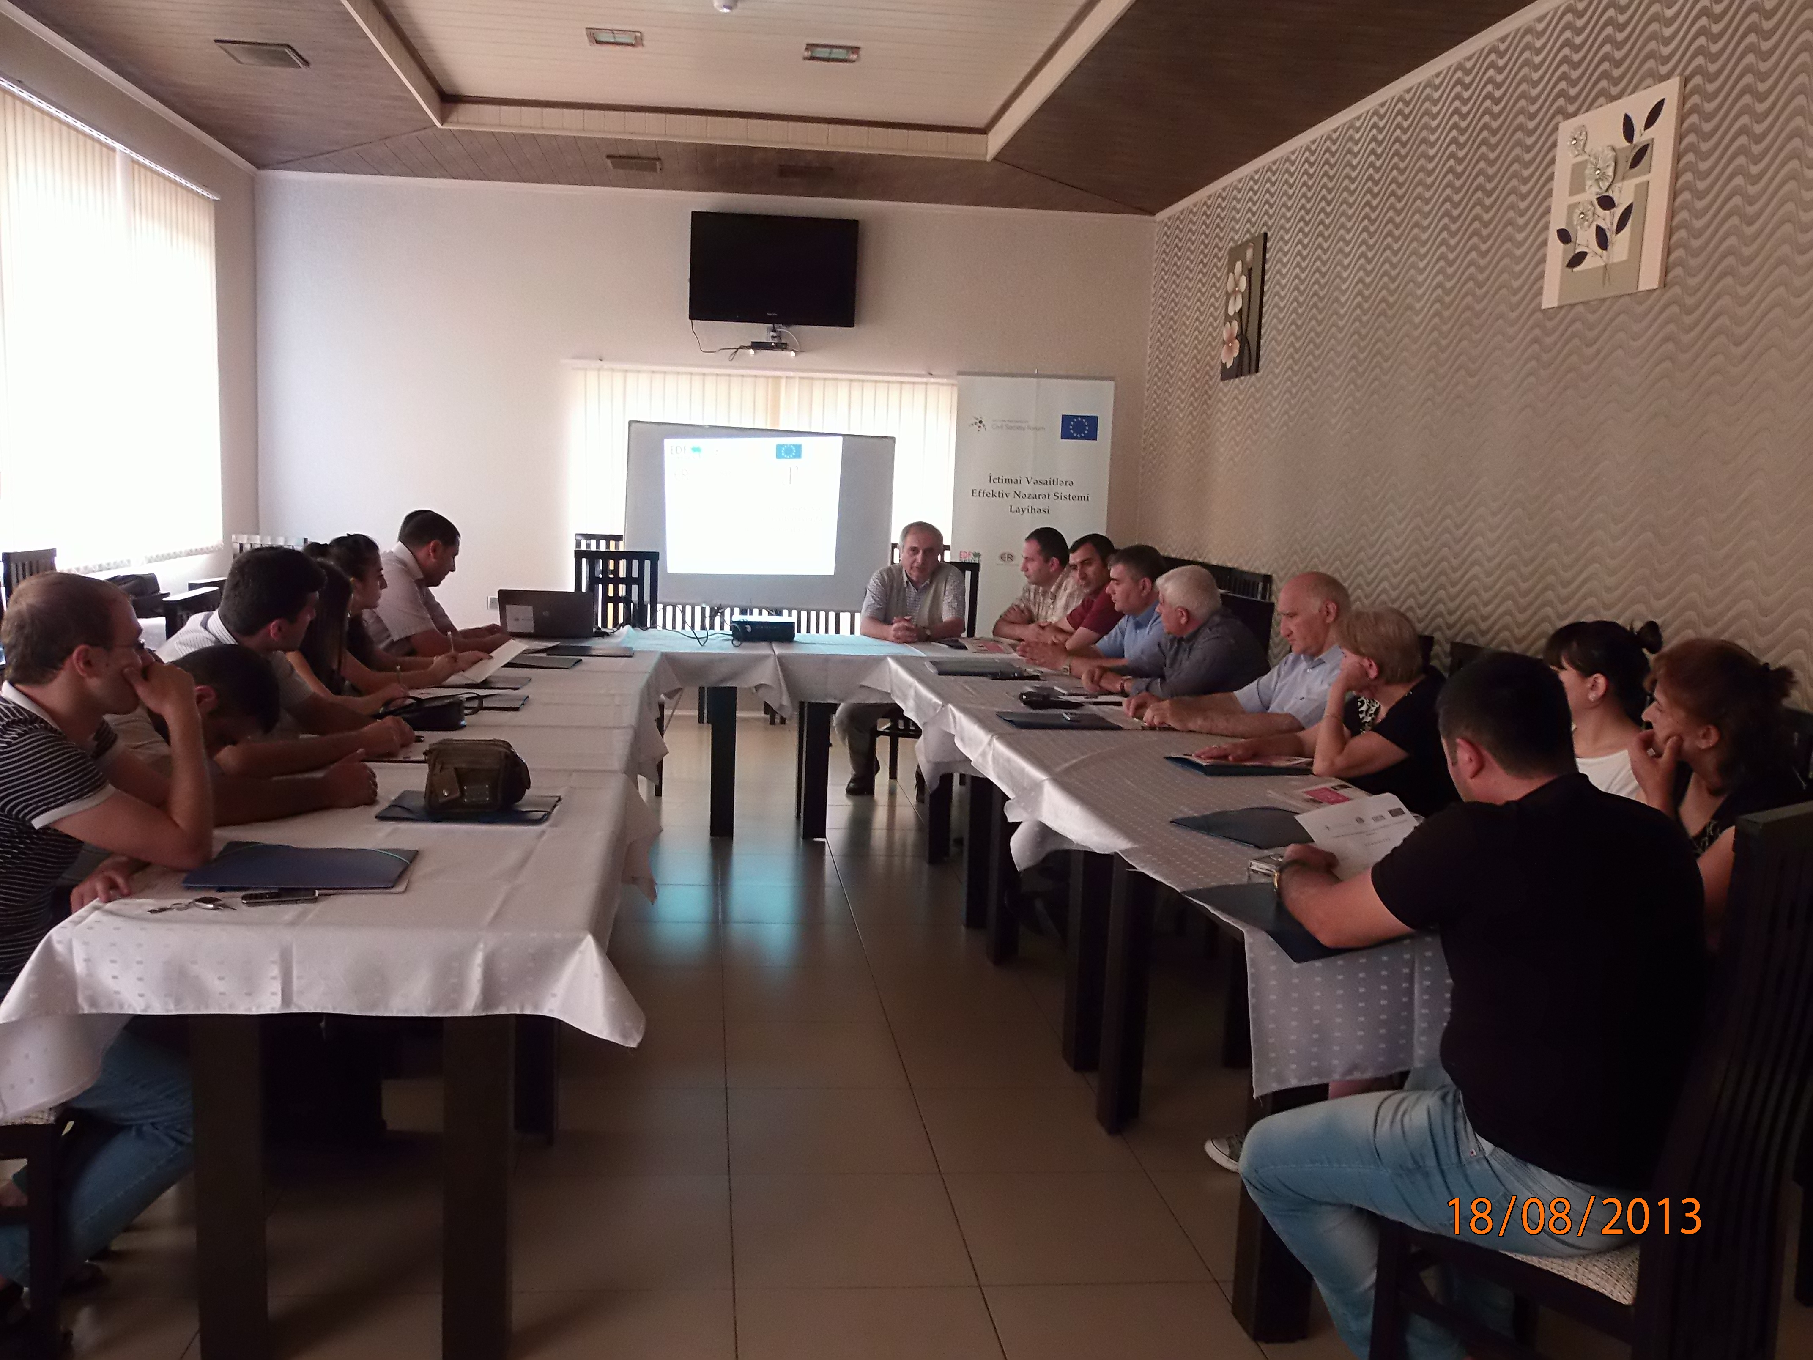
Economic Researches Center (ERC) organized the seminar on the topic of public finance management and public participation in Sheki 18 August 2013.

Opening the event, Project Director Sabit Bagirov spoke about the project aims and objective of the workshop. During his presentation on public finance institutions, their role in the budgetary process and opportunities for public participation in this process, Gubad Ibadoglu, Project Expert and ERC Board Member informed meeting participants about public finance and budgeting system, essence of public finances, public finance management, agencies responsible for public finance audit and their functions, forms and opportunities of public participation in the budgetary process and oversight over its implementation.

The event went on with the Q&A. More than 15 representatives from the local civil society, EaP CSF Azerbaijan National Platform and the media were in attendance.

Conference organized on "External control over public finance"

On 17 January 2014, the ESPFC project organized one-day conference to introduce international experience on external control over public finance and discuss the project recommendations, prepared to improve the functioning of Chamber of Accounts of the Azerbaijan Republic.

Opening the meeting, Project Director Sabit Bagirov briefed participants about objectives of the project, undertaken works as well as recommendations, prepared for improving the efficiency of external audit and strengthening the capacity of Chamber of Accounts.

Vahid Ahmadov, Member of the Standing Committee on Economic Policy of the National Assembly, Federico Berna, Head of the Cooperation Section at the European Union Delegation to Azerbaijan, Faig Nacafov, Head of Department of Law and Civil Service of Chamber of Accounts of Azerbaijan, Olaf Heidelbach, Programme Manager at the European Union Delegation to Azerbaijan welcomed the participants, spoke about the importance of the project and underlined the benefit of the recommendation package in terms of improving work efficiency of Chamber of Accounts and effectiveness of external control over public finance.

During the first session, dedicated to the implementation of external audit, Rashad Hasanov, expert of the Center for Economic and Social Development (CESD) spoke about the analysis of practising external control and made relevant recommendations. CESD Chairman Vugar Bayramov made his speech and recommendations on the analysis of budgetary discussions in the Parliament.
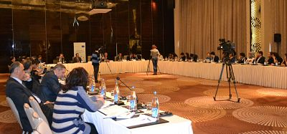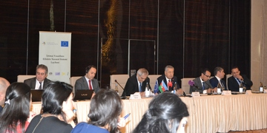

In the second session featuring the improving of the legislation, Zohrab Ismayil, Chairman of Public Association for Assistance to Free Economy (PAAFE) talked about external control over public finance, while PAAFE expert Kenan Aslanli presented international experience. Gubad Ibadoglu, expert of Economic Researches Center reviewed findings on the analysis of legislation and put forward his recommendations. Faig Najafov, Head of Department of Law and Civil Service of Chamber of Accounts expressed the opinion of Chamber on the recommendations, prepared in the project framework. Following the speeches, the meeting participants voiced their questions and suggestions.

The event was attended by members of the Parliament, representatives from Chamber of Accounts, various ministries, international organizations, civil society and the media.

Radio discussions held on the topics of public finance management and control

The first radio discussion in the project framework was held on “Obyektiv TV” 26 July 2013. Anchorman Hafiz Babali debated the issues about improving the activity of Chamber of Accounts and increasing the efficiency of external audit with Project Director Sabit Bagirov as well as experts Kanan Aslanli and Rashad Hasanov.

Video recording of the program can be found at the following link: http://youtu.be/-a763cLZPqc

Held on Azadlig Radio (Radio Liberty) 08 February 2014, the second radio program was dedicated to the discussion of recommendations, prepared ​​by project experts on improving the activity of Chamber of Accounts as well as efficiency of external audit. Reprsentatives of Public Association for Assistance to Free Economy Zohrab Ismayil and Kanan Aslanli, Member of the Parliament Zahid Oruj (joined by phone) were guests of the program.

Video recording of the program is available on the following link: https://www.youtube.com/watch?v=-X8qPLhqrmA&feature=youtube_gdata_player

The publication is prepared by Entrepreneurship Development Foundation under the European Commission funded Effective System of Public Finance Control Project, which aims to enhance the effectiveness of external scrutiny and audit. Its contents don’t reflect the views of the European Commission. Comments are welcome and should be addressed to Editor Farid Malikov by email at espfcp@gmail.com or by phone 00994 12 490 05 66.
Copyright 2014 Entrepreneurship Development Foundation

